FOR IMMEDIATE RELEASE

NEW LIGHTWEIGHT LG GRAM LAPTOPS MAXIMIZE PERFORMANCE FOR SMALL- AND MEDIUM-SIZED BUSINESSES

LINCOLNSHIRE, Ill., April 30, 2020 – The new “LG gram for business” series of laptop computers from LG Business Solutions USA provides small- and medium-sized businesses full-featured, high-performance laptops with a sleek ultra-light-weight design.
Available in 14-, 15.6- and 17-inch models, plus a 14-inch convertible touchscreen version, every LG gram laptop is ultra-portable, measuring less than 0.7 inches thick and weighing less than three pounds. The series offers extended battery life of 17 to 20.5 hours, depending on the model, while providing all the power and features necessary to meet the needs of virtually every business user, from coding to digital content creation.

“The LG gram for business series is designed to excel at every task a modern business professional might encounter, while being very light weight and having military-grade durability,” said Stephen K. Hu, LG Business Solutions USA’s head of IT business development. “At a time when more and more meetings are being held virtually and employees are more likely to work from home, it pays off for businesses to provide their employees reliable, powerful laptops with extended battery life to meet their demanding daily needs.”

At the heart of the new series is the 10th Generation Intel® Core™ processor with Intel Iris® Plus graphics and up to 16GB of dual-channel DDR4 memory. Users will marvel at how smooth demanding digital content appears with Iris Plus built in, while content creators will love having the speed and power to edit 4K video on-the-go and Thunderbolt 3 Power Delivery (PD) that enables the use of external displays or peripherals without a power outlet. The gram passed the MIL-STD-810G military standard durability test**, ensuring it is up to daily use and travel.

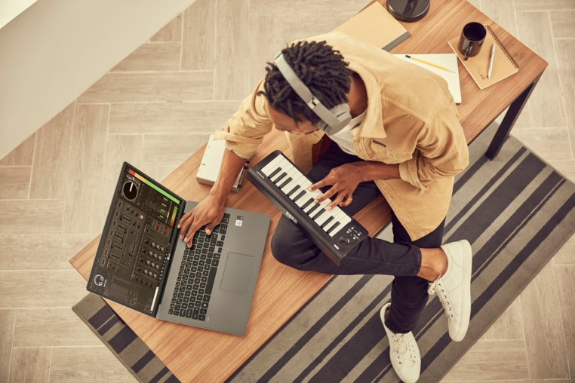
The 14- and 15-inch LG gram models each have two variations, featuring Intel Core i5 or i7 processors up to 1.30GHz with turbo speeds up to 3.90 GHz, up to 16GB of DDR4 ram, and up to 1TB of solid-state hard drive storage. Each model uses a Full HD 1920x1080 LG IPS LCD screen, includes a pair of 1.5W stereo speakers and offers one UFS/MicroSD, one HDMI, one USB-C, and multiple USB 3.1 ports. They each have an HD webcam, a 3.5mm headphone port, a backlit keyboard and fingerprint ID access. The 14-inch models house a 72Wh battery, while the 15-inch models have an 80Wh pack, and all four models weigh less than 3 pounds.

For employees and businesses requiring greater versatility, the LG gram also comes in a two-in-one model with a 14-inch convertible touchscreen. It features an Intel Core i7 processor pumping out 1.80GHz and up to 4.90GHz turbo, Intel® UHD Graphics, 16GB of DDR ram, a 512GB solid state hard drive and a Full HD 1920x1080 LG IPS LCD screen with Corning® Gorilla® Glass 6. It uses a 72Wh battery that delivers up to 20.5 hours of life* and comes with a stylus. Ports include microSD, USB-C, USB 3.1, and a 3.5mm headphone jack.

The 17-inch LG gram model is powered by an Intel Core i7 processor running at 1.30GHz with 3.90GHz available in turbo, the laptop offers up to 1TB of solid state storage, 16GB of DDR4 ram, and an 80Wh battery that delivers up to 17 hours of use. Their LG IPS screens feature enhanced 2560x1600 WQXGA resolution. Ports include microSD, USB-C, USB 3.1, and a 3.5mm headphone jack.

The 14- and 15-inch models are available in dark silver, and the 17-inch model is available in dark silver and white.

For additional information, please click here. And for images, please click here.

*Based on 2014 MobileMark® testing conducted under normal usage conditions in an Internet-enabled environment. Measurement conditions include brightness (150 nit), document work (Adobe, Excel, Word, PPT, Outlook etc.), and standby state (50 percent). Maximum usage time may change depending on product configuration, conditions of use and environment.

***Passed 7 different MIL-STD 810G Tests for durability conducted by KOLAS Labs that conforms to U.S. military standards. Compliant with the following methods for MIL-STD-810G: 500.6 Procedures I and II - Low pressure (altitude); 501.6 and 502.6 Procedures I and II - Temperature; 509.6 - Salt fog; 514.7 - Vibration; 516.7 - Shock; 516.7 - Drop; 510.6 - Dust. Device may not perform as tested in all conditions. Test performed in controlled environment. Do not attempt.

###

About LG Business Solutions USA
The LG Electronics USA Business Solutions division serves commercial display customers in the U.S. lodging and hospitality, digital signage, systems integration, healthcare, education, government and industrial markets. Based in Lincolnshire, Ill., with its dedicated engineering and customer support team, LG Electronics USA Business Solutions delivers business-to-business technology solutions tailored to the particular needs of business environments. LG Electronics USA Inc., based in Englewood Cliffs, N.J., is the North American subsidiary of LG Electronics Inc., a $53 billion global force in consumer electronics, mobile communications, home appliances and air solutions. LG is a 2020 ENERGY STAR® Partner of the Year-Sustained Excellence. For more information, please visit www.LGSolutions.com.

Media Contacts:

LG Electronics USA

Kim Regillio
847 941 8184
kim.regillio@lge.com

Bob Griffin
212 481 3456 x16
bob@griffin360.com

